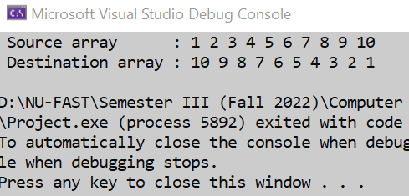TITLE Task1

INCLUDE Irvine32.inc

INCLUDE macros.inc

.data

source WORD 1,2,3,4,5,6,7,8,9,10

destination WORD LENGTHOF source DUP(?)

.code

main PROC

mov ecx, LENGTHOF source

mov esi, 0

mWrite " Source array : "

sourceToStack:

movzx eax, source[esi]

add esi, 2

push eax

Call WriteDec

mWrite " "

loop sourceToStack

Call Crlf

mov ecx, LENGTHOF destination

mov esi, 0

mWrite " Destination array : "

StackToDestination:

pop eax

mov destination[esi], ax

Call WriteDec

mWrite " "

loop StackToDestination

Call Crlf

exit

main ENDP

END main

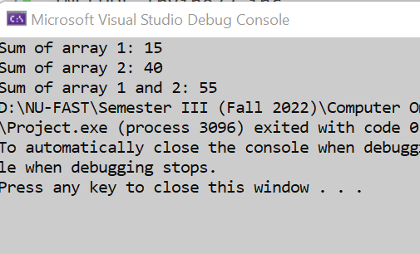TITLE Task2

INCLUDE Irvine32.inc

INCLUDE macros.inc

.data

array1 DWORD 1,2,3,4,5

array2 DWORD 6,7,8,9,10

sum1 = 0

sum2 = 0

sum12 = 0

.code

main PROC

Call Array12Sum

exit

; 1st procedure

Array1Sum PROC

mov esi, 0

mov ecx, 5

mov ebx, sum1

mWrite "Array 1 : "

l:

mov eax, array1[esi]

add ebx, eax

add esi, 4

Call WriteDec

mWrite " "

loop l

mov eax, ebx

Call Crlf

mWrite "Array 1 Sum : "

Call WriteDec

push eax

ret

Array1Sum ENDP

; 2nd procedure

Array2Sum PROC

Call crlf

Call crlf

mov esi, 0

mov ecx, 5

mov ebx, sum2

mWrite "Array 2 : "

l:

mov eax, array2[esi]

add ebx, eax

add esi, 4

Call WriteDec

mWrite " "

loop l

mov eax, ebx

Call Crlf

mWrite "Array 2 Sum : "

Call WriteDec

mov ebx, eax

push eax

ret

Array2Sum ENDP

; 3rd procedure

Array12Sum PROC

Call Array1Sum

pop eax

mov ebx, eax

Call Array2Sum

pop eax

add ebx, eax

Call Crlf

Call Crlf

mWrite "Sum of both arrays: "

Call WriteDec

ret

Array12Sum ENDP

main ENDP

END main

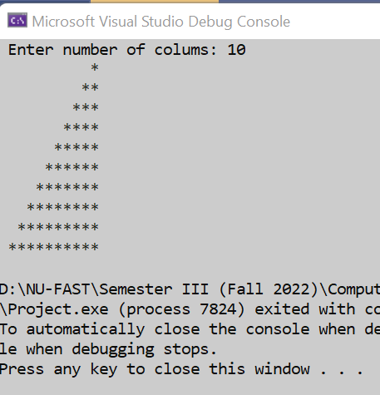TITLE Task3

INCLUDE Irvine32.inc

INCLUDE macros.inc

.data

lbound DWORD 1

ubound DWORD ?

.code

main PROC

mWrite " Enter number of colums: "

Call ReadDec

mov ecx, eax

mov ubound, eax

Call PrintStarics

exit

main ENDP

PrintStarics PROC USES ecx

l1:

push ecx

mov ecx,ubound

dec ubound

; loop for spacing, 5, 4, 3, 2 ,1

l3:

mWrite " "

loop l3

; loop for printing starics, 1, 2, 3, 4, 5

mov ecx,lbound

inc lbound

l2:

mWrite "\*"

loop l2

pop ecx

call crlf

loop l1

ret

PrintStarics ENDP

END main

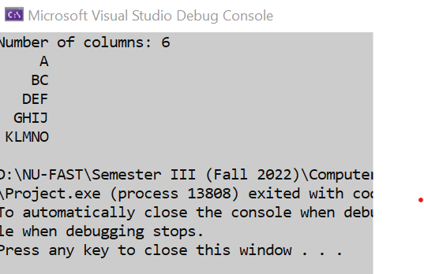TITLE Task4

INCLUDE Irvine32.inc

INCLUDE macros.inc

.data

var1 BYTE 'A',0

spc BYTE ' ',0

var dword 1

var2 dword 5

col DWORD ?

col2 DWORD ?

.code

main PROC

mWrite "Number of columns: "

mov eax, col

Call ReadDec

call printer

exit

main ENDP

printer PROC uses eax

sub eax,1

mov ebx,eax

mov ecx,eax

l1:

push ecx

mov ecx,ebx

dec ebx

l2:

mWrite " "

loop l2

mov ecx,var

inc var

l3:

mov edx, OFFSET var1

Call WriteString

inc var1

loop l3

pop ecx

call crlf

loop l1

ret

printer ENDP

END main

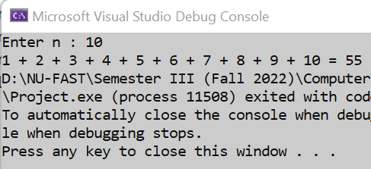TITLE Task5

INCLUDE Irvine32.inc

INCLUDE macros.inc

.data

.code

main PROC

Call Func

exit

Func PROC

mov ebx, 0

mWrite "Enter n : "

Call ReadDec ; eax = n

mov ecx, eax ; ecx = n

l:

mov ebx, ecx

push ebx

loop l

mov ecx, eax

mov eax, 0

mov edx, 0

l2:

pop ebx

mov eax, ebx

Call WriteDec

add edx, eax

cmp ecx, 1

je outt

mWrite " + "

loop l2

outt:

mov eax, edx

mWrite " = "

Call WriteDec

ret

Func ENDP

main ENDP

END main